


https://1drv.ms/f/c/5904c965059b671f/EpWLEJouf6hJu0GxyvLmAUMBhsDsMnvebHAWPcZ2emYE9A?e=rnYriB

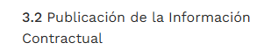

https://1drv.ms/f/c/5904c965059b671f/EgHsJ3-adaRCmsTEeNzax3kBTct6pyjJ47euM94Z0Lu0sg?e=FXcmFH

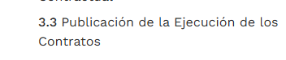
https://1drv.ms/f/c/5904c965059b671f/Eo-H2J3NEl9GoG-KEqxhm7oBhKojC_qPmxheWD2zHadTDQ?e=QfSJu8


https://1drv.ms/f/c/5904c965059b671f/Eor-7gVEWMpMryzSm7LUxSABdt13DaLXQPzDQME7pe0KYw?e=0pfLuh

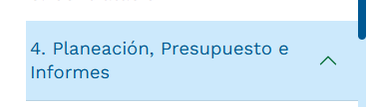
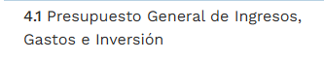
https://1drv.ms/f/c/5904c965059b671f/EoeDVYkVTLJCkV7E9h4R0gUB8cYKgcwia_d1sfbEeEv5zQ?e=RiFCqQ


https://1drv.ms/f/c/5904c965059b671f/EpCT3QDH7y1Hgh4HVweoBugB5jTQRtOLxPVnmF7ZUlJTmA?e=kq2Ei4

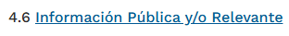
https://1drv.ms/f/c/5904c965059b671f/EpkWZAZghWlKrtdF_fTv-c4BSMW2VvuZqu2n8gpS1OJbUw?e=4b17lz

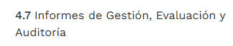
https://1drv.ms/f/c/5904c965059b671f/Et0qrdhbG5VGshlIEzmgrVIBOhmnv0i5dlmGDQdLM9f18g?e=n6jxOf

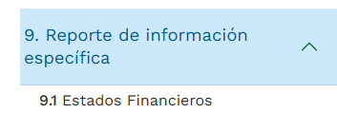
https://1drv.ms/f/c/5904c965059b671f/Ev3dBBufTKZOokNwBhEqp-sBL7yNrja_QhMiNXCqNxf4pg?e=T3TyC4

